**Week 1  
  
Exhaustive Analysis of Indian Agriculture Using Power BI**

**Name: Abhiraj Singh**

**AICTE ID: STU64136145114e11678991685**  
  
  
**Step 1: Power BI Desktop Installation**

1. **Downloading Power BI Desktop:**
   * **From the Microsoft Store:**
     + Navigate to the Power BI Desktop page on the Microsoft Store.
     + Click **"Get"** or **"Install"** to download and install the application.
   * **Direct Download:**
     + Visit the [Power BI Download Center](https://www.microsoft.com/en-us/download/details.aspx?id=58494).
     + Choose the appropriate version (32-bit or 64-bit) based on your system specifications.
     + Run the downloaded installer and follow the on-screen instructions to complete the installation.
2. **Installation Process:**
   * Locate the downloaded installer file.
   * Double-click to execute the installation.
   * Follow the guided setup process to finalize the installation.

**Step 2: Launching Power BI Desktop**

* Open Power BI Desktop by selecting the application.
* Upon launching, the Power BI splash screen will appear.

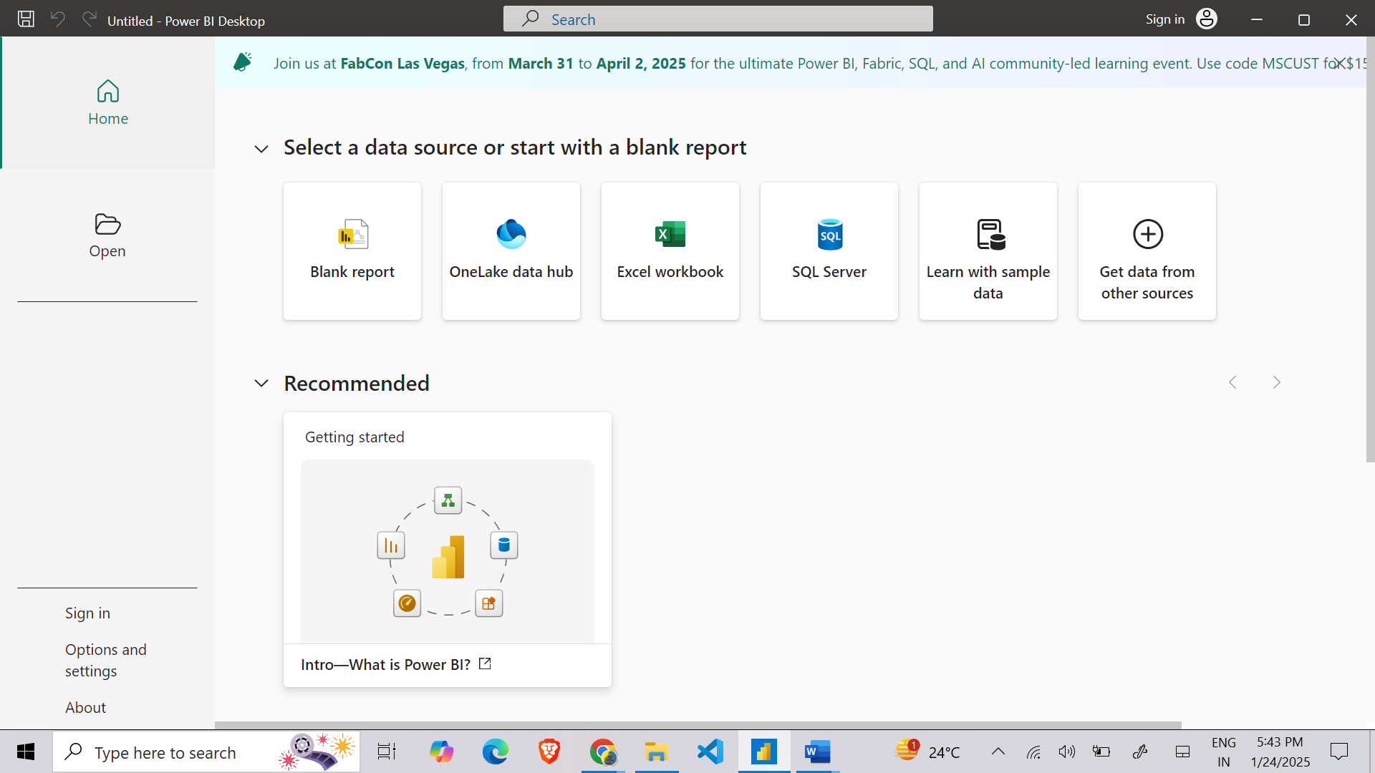

* Select **“Blank Report”** to initiate a new project.  
  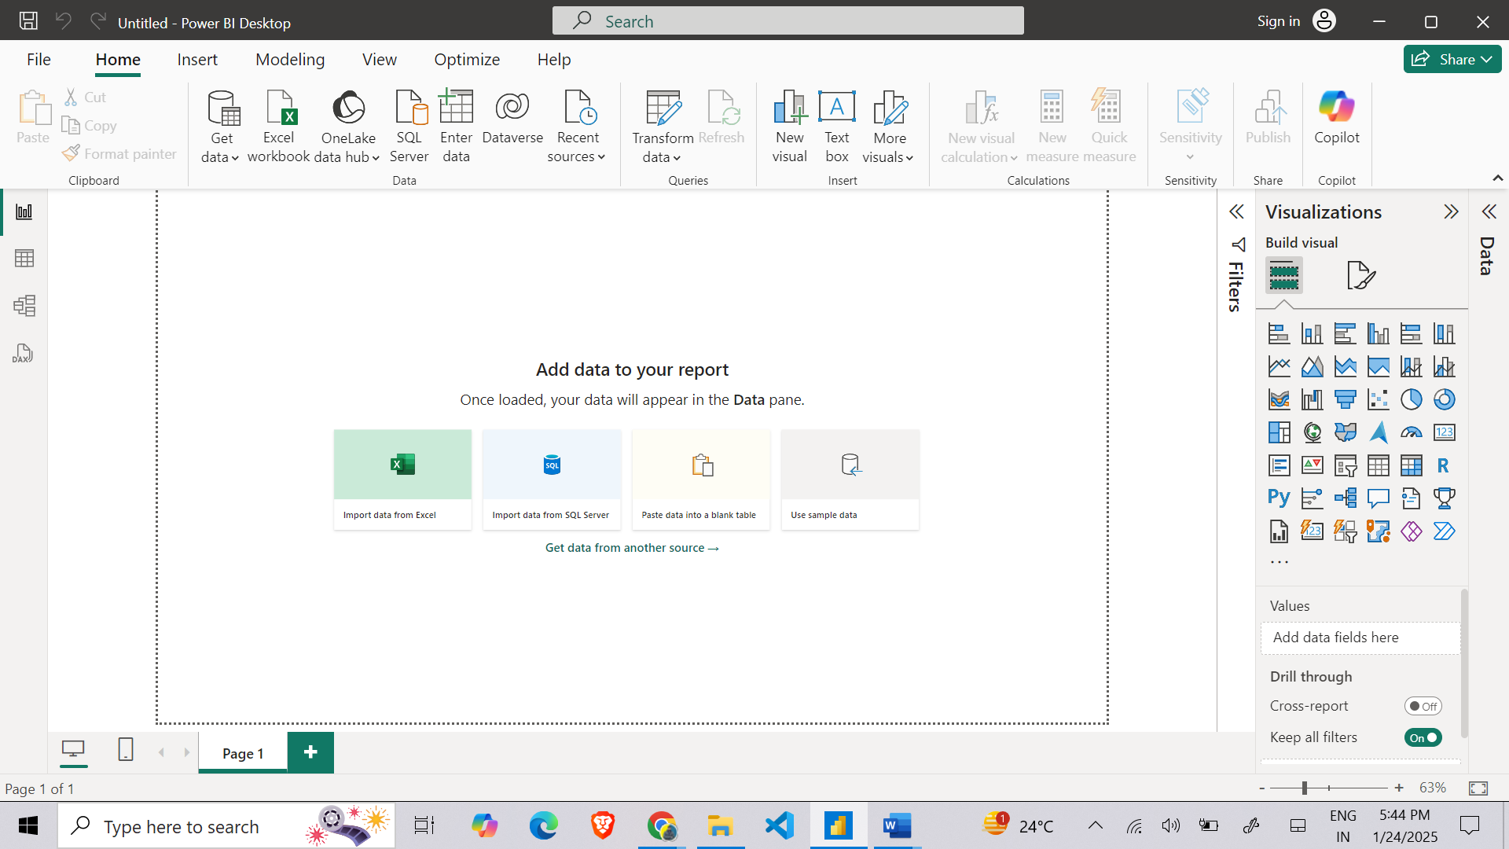

**Step 3: Acquiring the Dataset**

* Download the required CSV dataset.
* Save the file in an easily accessible location (e.g., Desktop, Downloads).

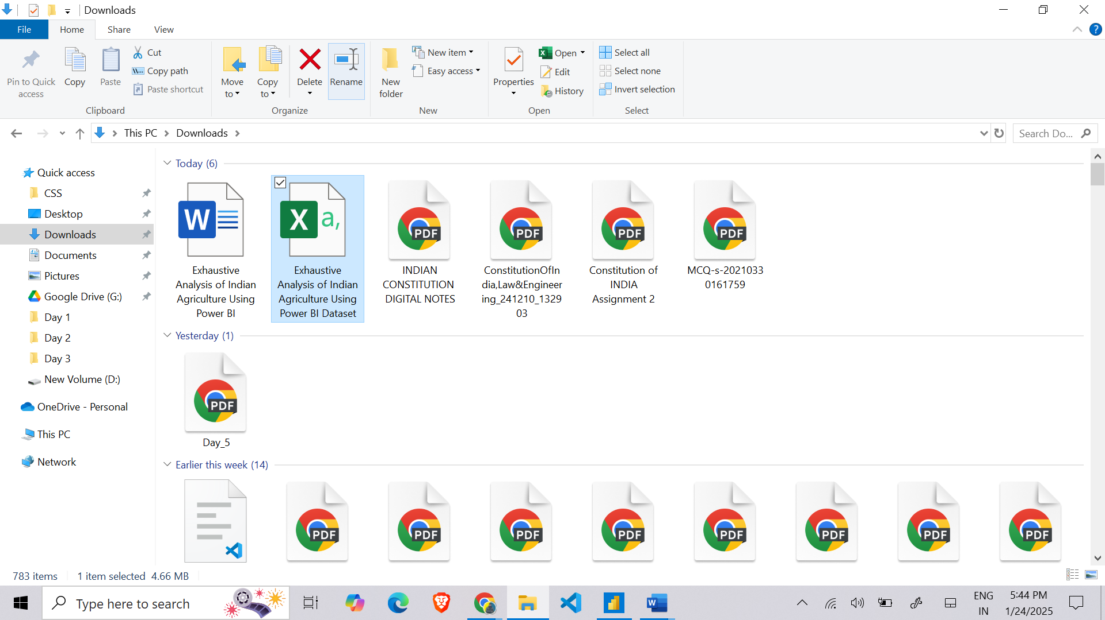

**Step 4: Importing Data into Power BI**

1. Navigate to the **Home** tab and select **“Get Data”**.
2. Choose **“Text/CSV”** as the data source.
3. Browse and select the saved CSV file, then click **“Open”** to proceed.  
   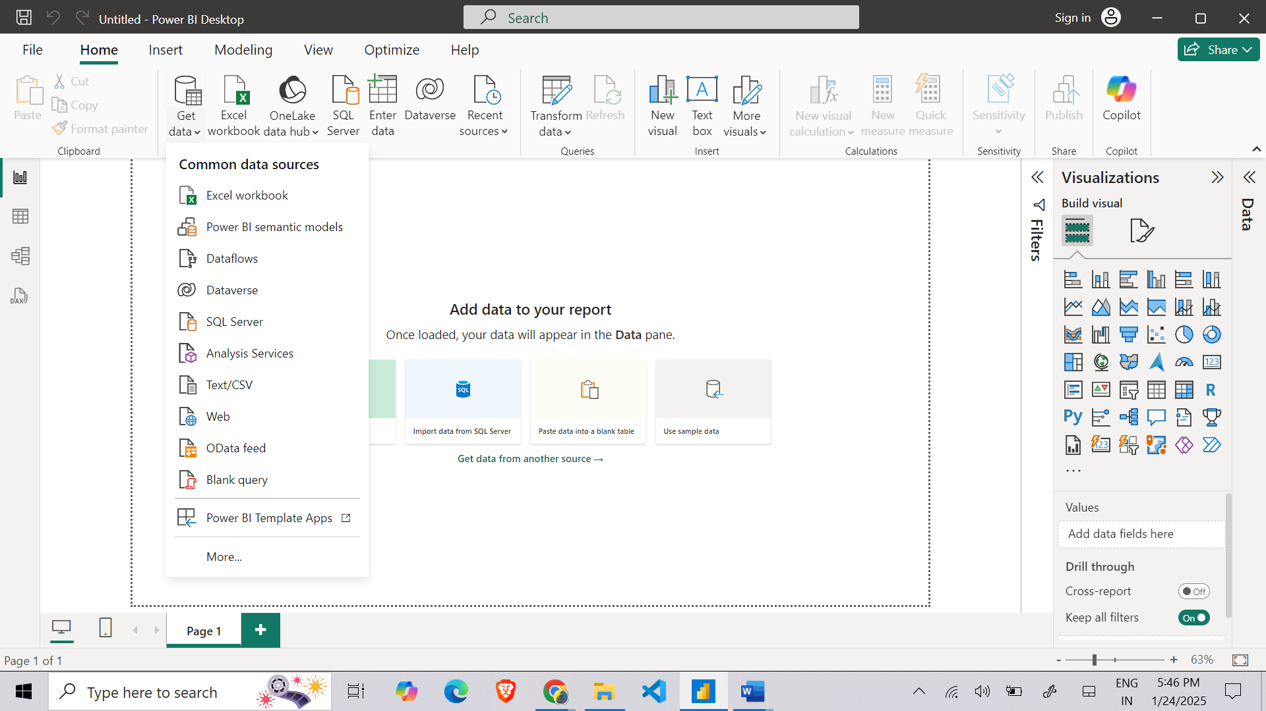

**Step 5: Data Loading and Visualization**

* Review the data preview to verify accuracy.
* Click **“Load”** to import the data into Power BI.  
  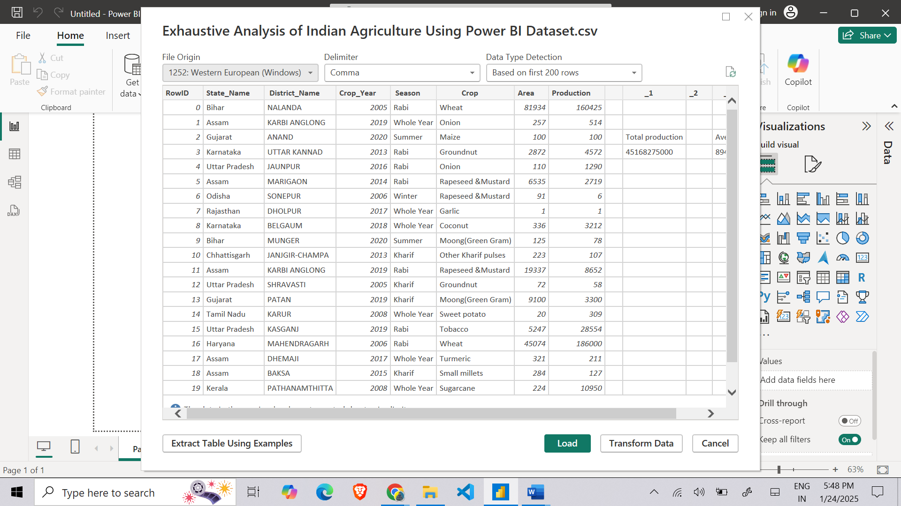
* Once imported, the dataset will be available in the **Fields** pane.  
    
  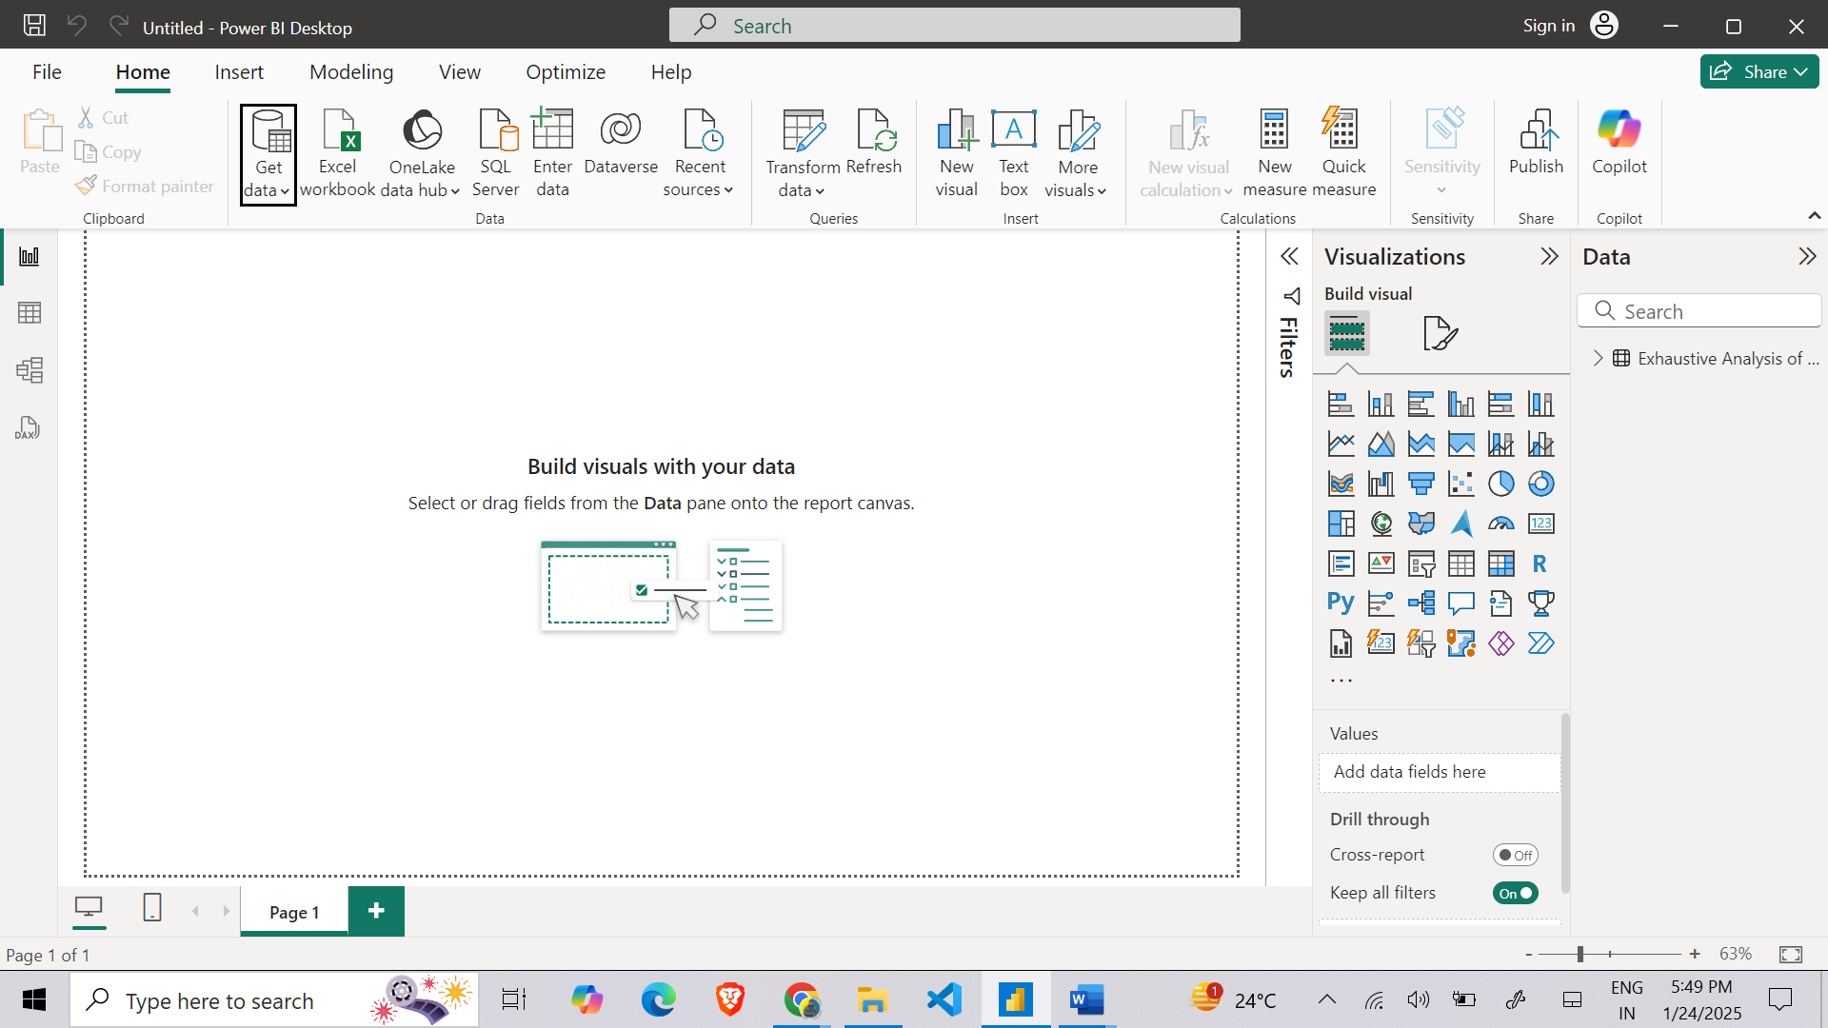

**Power BI Views:**

1. **Report View (📊):**
   * Primary workspace for creating visualizations, reports, and dashboards.
   * Drag and drop fields to the canvas and customize visualizations.
2. **Data View (📋):**
   * Displays raw data in a tabular format, enabling data validation and modifications.
3. **Model View (🔗):**
   * Represents relationships between tables and datasets for complex data modeling.

**Step 6: Data Transformation and Cleaning**

1. Click **“Transform Data”** to access Power Query Editor.  
   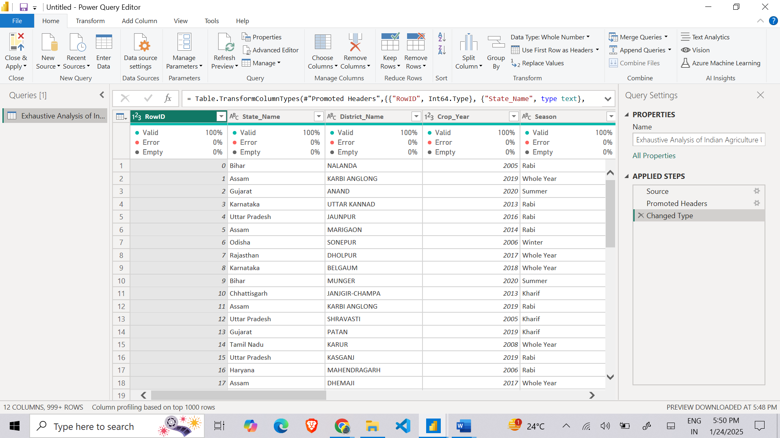
2. Perform necessary data preparation tasks, including:
   * **Removing redundant columns** to streamline the dataset.
   * **Renaming columns** for clarity and consistency.
   * **Adjusting data types** to ensure accuracy (e.g., Date, Text, Number).
   * **Handling missing values** by replacing or removing them.
   * **Splitting or merging columns** to structure data effectively.
   * **Filtering records** based on specific criteria.
   * **Eliminating duplicate entries** to maintain data integrity.

**Step 7: Data Quality Assessment**

* Navigate to the **View** tab and enable **“Column Quality”** to assess data integrity.  
  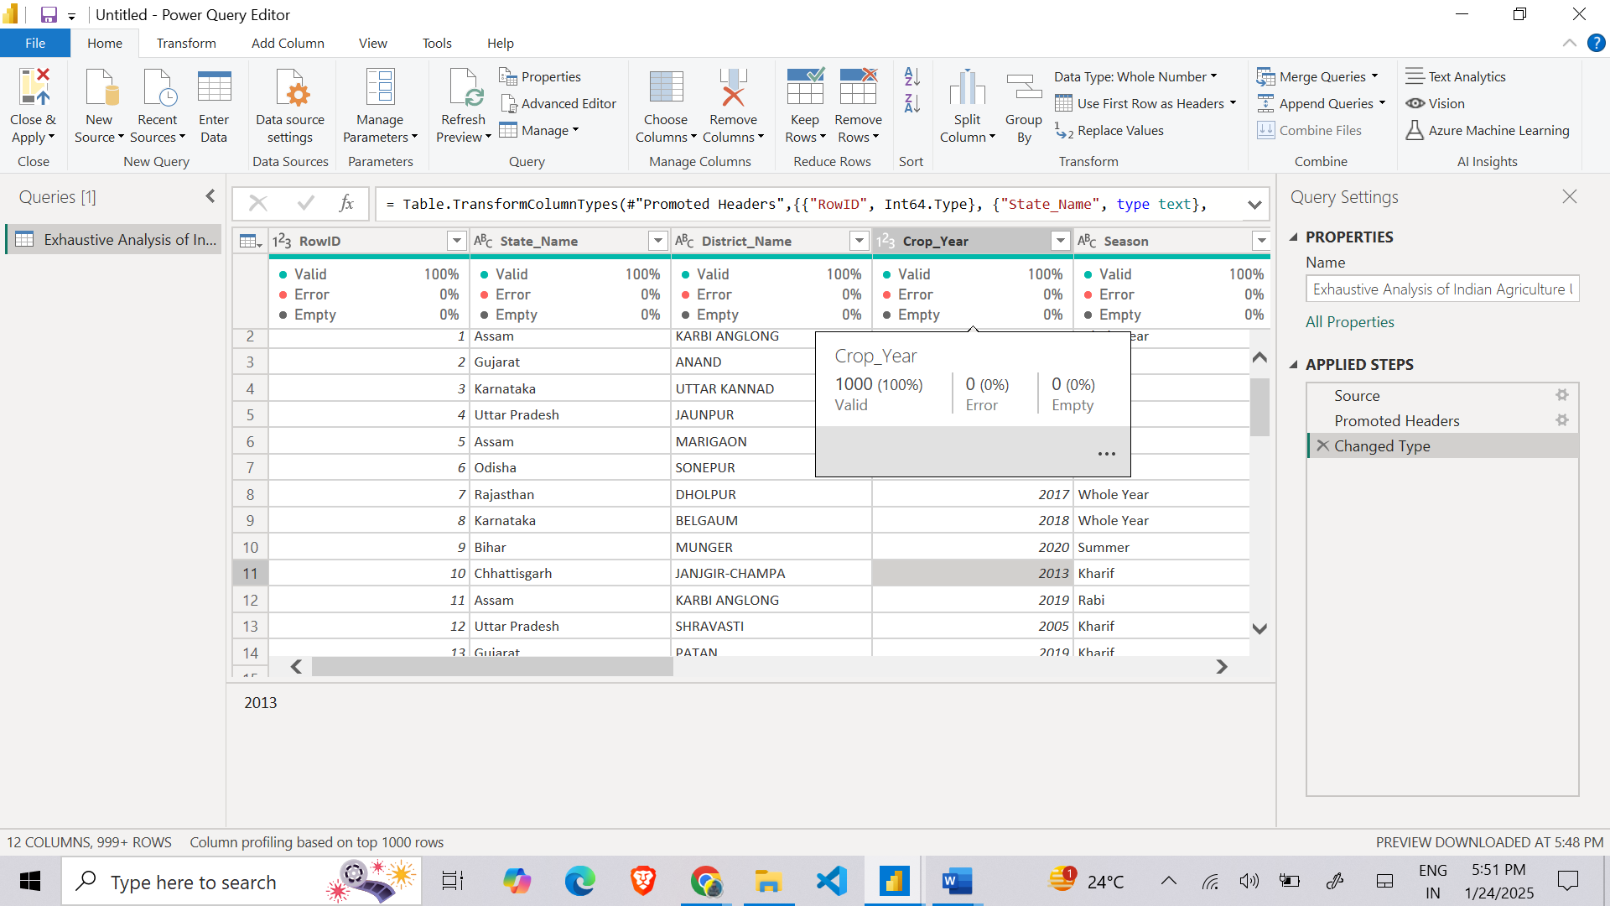
* Power BI will provide quality indicators such as:
  + **Valid (Green):** Percentage of correctly formatted values.
  + **Error (Red):** Percentage of erroneous or inconsistent data.
  + **Empty (Gray):** Percentage of missing values.
* Resolve detected issues through appropriate data cleaning actions.

**Step 8: Applying and Saving Changes**

* Once data transformation is complete, click **“Close & Apply”** to finalize changes and return to the main Power BI interface.